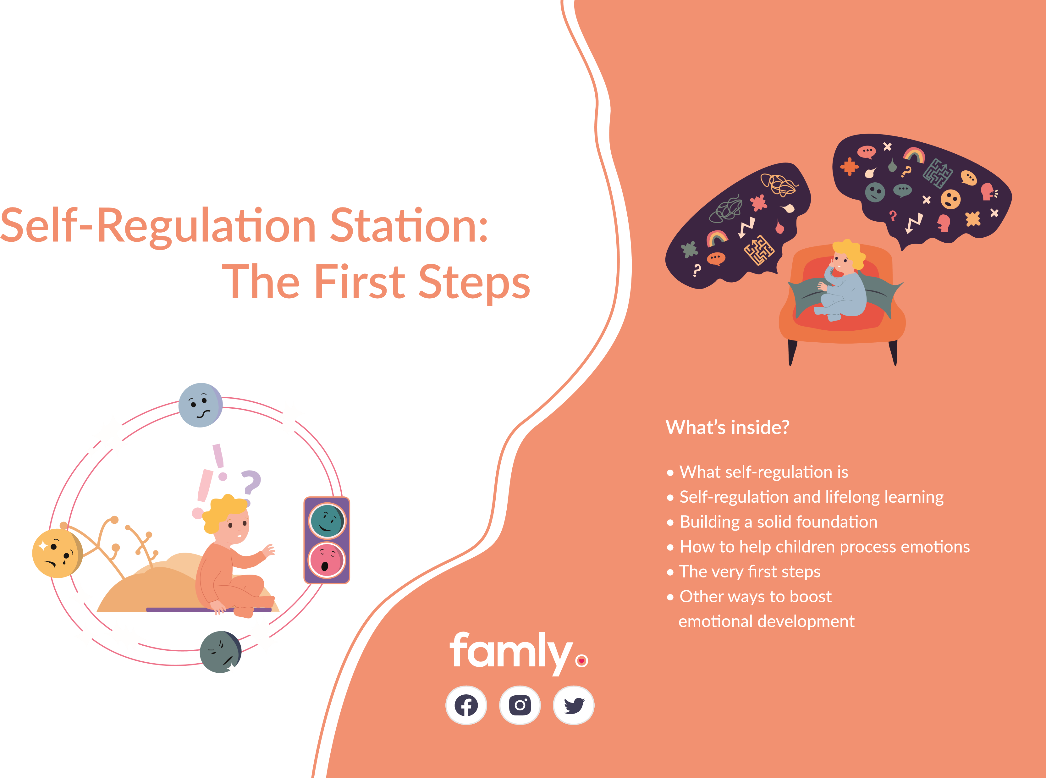
What‘s this guide all about?

As an Early Years educator, you’ve definitely seen your fair share of emotional outbursts. You know firsthand that children need a little helping hand when it comes to understanding and processing their own emotions — and that starts with self-regulation.

Self-regulation is how we react and control our emotions. It’s knowing how to manage your emotions and behaviour in any situation you might find yourself in - and it’s something that we aren’t born with. Children have to
You play a huge role in helping children understand,
process and control what they’re feeling. That’s why we’ve put together this guide to help you understand the importance of self-regulation and why it sits at the core of children’s emotional development.
learn, and that’s where you come in.

We’ll dive into what self-regulation actually means, how to value and understand when a child has a big emotion, and tips and tricks to use in your setting to start children on their self-regulation journey. And we’ve got some pearls of wisdom from Early Years experts and consultants to help you along the way.

Our contributors

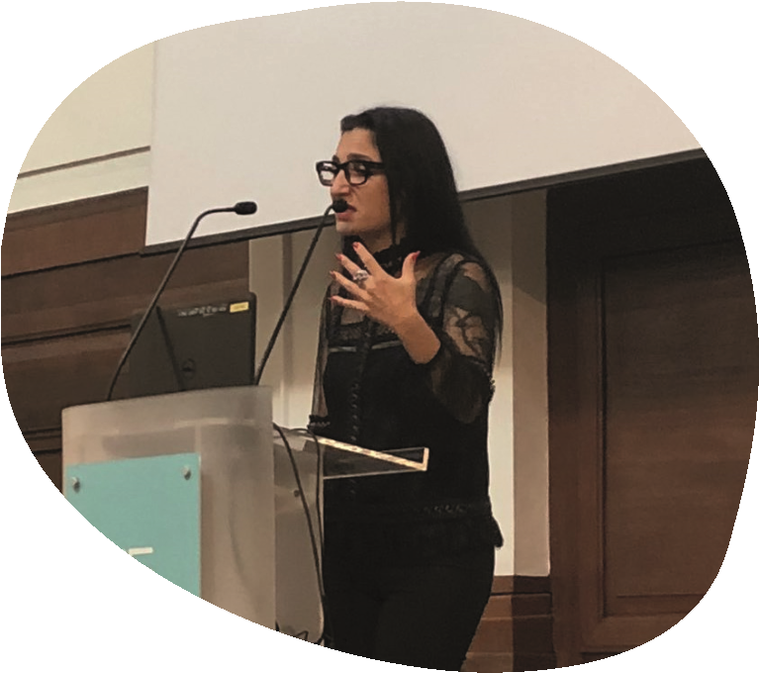
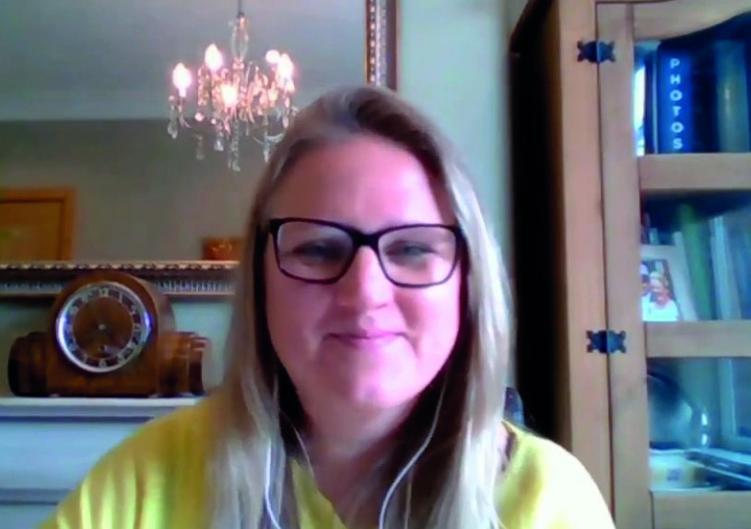

Katrina is the director of Siren Films, the UK’s leading creators of educational videos for professionals in the Early Years. Siren Films delve into child development to give EY professionals a deep understanding of Early Years care, and give them food for thought to implement into their daily practice.
Katrina McEvoy

Ursula Krystek-Walton

Ursula is the Head of Early Years at Thrive Childcare and Education, and
has a wealth of knowledge with her 20 years of experience in the sector.
She has a first class BA Honours in Childhood Studies, and has worked
alongside Mine to create a self-regulation in practice toolkit.
Mine is a lecturer, award-winning author and trainer. She has worked
in the field of early childhood education and care for over 17 years.
She is currently undertaking a PhD in Early Childhood Education and
neuroscience to her work in the complex and challenging subject of
infant brain development.
Dr
. Mine Conkb
ay
ir
Ur
sula Kryste
k-
Wa
lton
Katrina
Mc
Evoy

Breaking self-regulation down

When we talk about self-regulation, there’s a lot more to it than just understanding when you’re angry or sad. From the moment a child is born, every response they have becomes part of their self-regulation journey.

There are 5 different areas of self-regulation, and when we learn these essential skills, we carry them with us

into adulthood.

The 5 areas of self-regulation:
Biological – A child’s energy levels and how they respond to what’s around them
Emotional – Controlling positive and negative emotions like excitement and fear
Social – Knowing and understanding social cues, and how to act in social situations
Prosocial – Knowing how to act with others and how to acknowledge their feelings
Cognitive – How a child processes their own thoughts and then uses that information

“For young children, this can be a real struggle. These 5 domains are massive asks of children if
they don’t have help or encouragement.”

Children are brand-new to the world, so we can’t expect them to understand how to control their emotions when they’re overwhelmed by a big a group of other children, or that being tired might make them short tempered and upset.

Of course, self-regulation isn‘t some skill-set that exists in a vacuum. It‘s one of the first big steps in how we learn to get a handle on our own emotions, and as we‘ll see on the next page, that‘s a lifelong learning journey”

Self-regulation as a stepping stone

If we look at our whole childhood journey, self-reg is one of the first big steps. Controlling emotions lays the foundation for later learning - like executive functioning, for instance.


Executive functioning is the set of skills that allow us to focus, keep organised and get things done. It’s also known as problem-solving, playing with an idea, thinking before acting, or staying focused. Self-regulation helps us understand our emotions, so that we can be stable enough to get anything done in the first place. We can’t get started with executive function before children know how to reflect on their emotions: What am I feeling? Why am I feeling this way, and what’s causing this? How can I calm down?
”Without self-regulation, children will not be able
to develop the essential skills they need to plan,
make goals and display self-control.”

Let‘s put that into context: Executive functioning includes the three main topics here:

- Working memory — How we hold on to bits of information.
- Mental flexibility — How we can change what we’re focused on as our situation or needs change.
- Self-control — How we can resist impulses and set goals for ourselves.
In short, self-regulation is key in helping children to thrive in later life. By encouraging and helping children to self-regulate, you’re helping them build that strong foundation.
So how do you learn to self-regulate?
Before we co-regulate children - in other words, give them a helping hand to understand their emotions before they can self-regulate - they need a solid base and a nurturing environment. Katrina McEvoy identifies the core elements to pay attention to:
  - Emotional warmth and security.

- When our brains develop, the neural pathways that fire most often are strengthened, while others wither away. If adults support babies to regulate their emotions, these pathways in the brain become well used, setting the child up to self-regulate later on.
- How to give this support? Attachments to key people at your setting leads children feeling free to be themselves, and to play and explore from a safe base.
  - Feelings of control and cognitive challenge
- Babies are born with key concepts that make them motivated. One is a need to control what happens to them. Once they learn that their actions influence and change what happens to them, they’re motivated to keep making those actions.
- They’re also motivated by challenges. Vygotsky believed children learn best when they try to make sense of things, or do activities close to the edge of their ability.
- What to do? You know when to scaffold and when to step back. Gently assist learning without constantly interfering - let them take learning into their own hands.
3. Opportunity and encouragement to speak and reflect on their own learning
- As Vygostky stated, most learning occurs through socialising. Good communication and social skills are absolutely key.
- Children also need to develop internal thought processes. This happens when they speak their thoughts out loud as they carry out actions and learn new things.
- How to help? Interactions children have with others are paramount - they’re encouraged to push themselves and keep going. Gentle encouragement from you is critical. Encouraging them to take control and persevere with different strategies works wonders.

Start the self-regulation journey
Building self-regulation skills can only happen when children feel safe, secure and motivated. Let’s look at how you can get started on helping the children in your care develop those essential skills.

Name, validate and understand a child’s emotion
- Tell the child exactly what the emotion they’re having is called.Tell them that you understand that they’re having this emotion, and that it’s completely okay. This is absolutely vital, as you can’t expect a child to self-regulate without a helping hand.
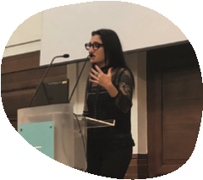
“ A simple ‘I understand that this frightens you’ is the first step
in helping a child begin their self-regulation journey.”
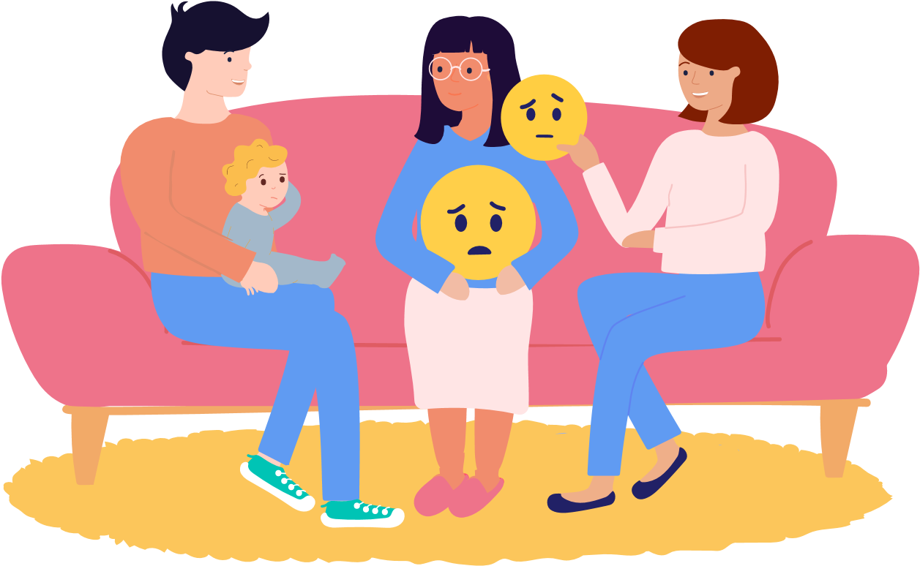
Create a self-regulation space
- Children need a safe, quiet and calming place toprocess their emotions, which supports them in developing self-regulation skills. Being surrounded by 30 children in a setting can be incredibly overwhelming, so having a calm, quiet space is key for children to bring themselves away from whatever is triggering them and back down to a calm state.
- Make a dedicated ‘self-regulation corner,’ separatefrom the reading nook or role-play corner. The space should be cosy, calm and quiet - maybe with headphones, blankets, cushions and props to support deep breathing - like breathing stars or feathers to blow up and down. Quite simply, it’s a safe, quiet place for them to process what emotion they’re trying to work through.

“It can be as easy as a pair of noise-cancelling headphones and a few cushions. What matters is that children know they can go there if they’re feeling stressed, anxious or upset.”
Think about next steps

- As co-regulator, it’s important to acknowledge that the learning doesn’t stop at naming the emotion and creating a self-regulation corner. Think about the ways you can extend the learning and help the child on their self-regulation journey.

- If a child is terrified of the gardener, for example, can you plan activities around the figure of a gardener? Can you ask the parents to talk about gardening at home? This all plays a role in allowing the child to understand Be reflective about the current practices in your setting
the emotions behind their fear, and to show them that
you are there and ready to support them.
“As a co-regulator your role is telling the
child that they’re alright, that you’re recog
-
nising them and all that they bring, and how
you can move forward together. And that’s
a toolkit that will be with that child for life.”
“If we immediately shut children
down without validating their emo
-
tions, [sensory issues] are exactly
the kind of issues that we can miss.”

- You know your setting and children the best, and should focus on their wellbeing first. Is the child reacting to something external? Could they have a sensory issue, and are you seeing any patterns?
- It’s up to you as the practitioner to assess the situation - if a child is having an outburst for example - and decide what the next steps are to help this child continue their self-regulation journey.

The first steps to self-regulation
- Let’s say a child has an outburst. They see a clown and it makes them cry hysterically. It’s important here to get down to the child’s level to ask them what’s wrong, and to avoid dismissing their fear.

- In this case, tell the child “I understand that that scares you, and that’s okay. That’s what we call fear.” This way, you’re naming the emotion, and you’re letting the child know that their emotion is validated.
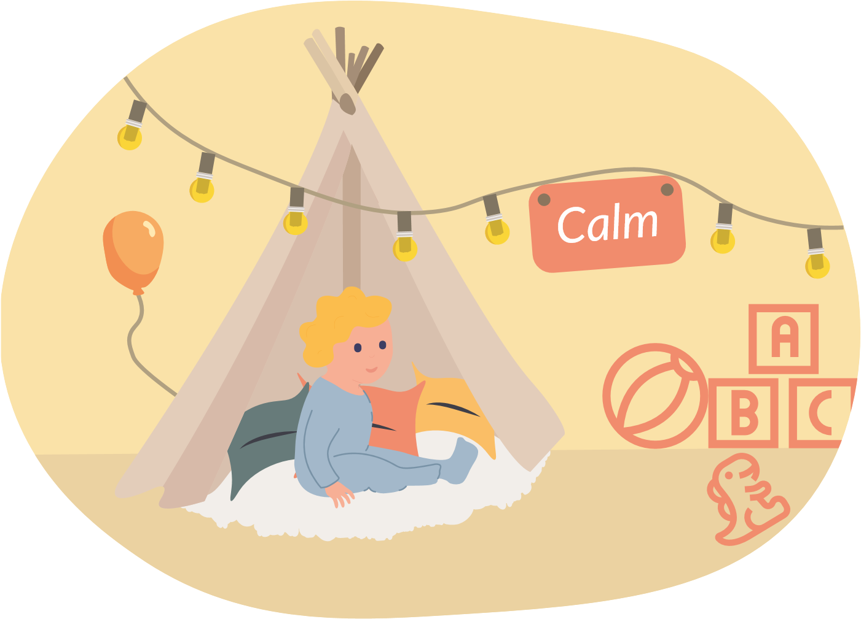
- Ask if the child would like to go to the special regulation space to deal with their emotion. It’s important to let them know they can process and deal with it in a quiet, calm environment, away from the action of the setting.
- The next time the child has an outburst or they feel it coming on, they’ll be able to recognise it. They’ll also be able to recognise that they might benefit from a little time in the quiet self-regulation space to calm themselves down without your help.

Stories that deal with emotional topics

Books can help introduce children to some of the bigger, scarier emotions, and give them a way to explore and process those feelings. Stories help put those big ideas into a context they can understand, and we have a great list of them here.
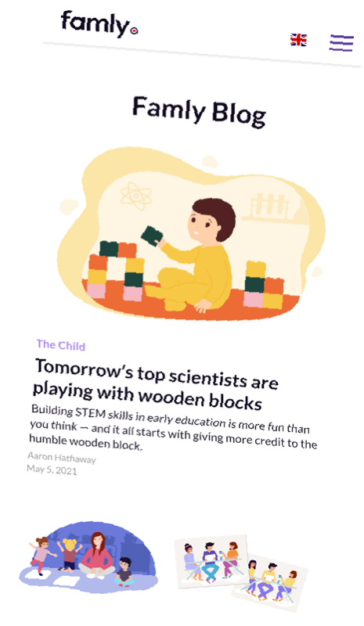
Helicopter Stories

Acting out emotions that are sitting on a child’s shoulders is another way for them to process and understand what’s going on around them. Letting
Other ways to develop children‘s
understanding of emotions

Now's not the time for extra
headaches
.
Famly helps you focus
on the children, not the paperwork.

Head t
o
famly.co/dem
o
t
o see
how a l
ittle bit of softwa
re can
make your day a lot easier.

Teaching empathy
Your response to children’s issues and worries has a huge impact, as they carry it with them into adulthood. By making sure you’re aware that the way you respond to emotions is nurturing and understanding, you can help raise empathetic, caring and emotionally developed adults. them act out an idea like grief or illness can be extremely beneficial for their emotional development, as it lets them explore the topic using their own movements and ideas.

