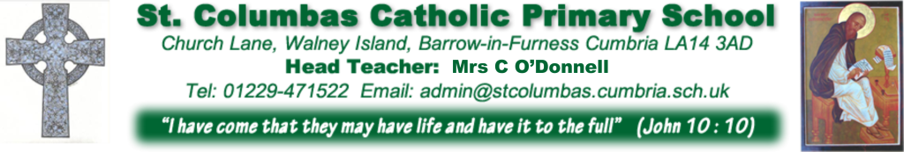

ST COLUMBA’S CATHOLIC PRIMARY SCHOOL 1916-2016
Dear Parents,
Happy New Year to you all, I hope you had a peaceful Christmas. This year 2016 is an extra special year in the life of St Columba’s School as it marks the 100th year that the school has been open. It feels exciting and a privilege to be head teacher during this time. We are planning special events to last the year and will need support from parents to make the celebrations extra special.
We will begin by sending home memory homework for children, parents or even grandparents to write down their memories and experiences of life in the school. It would be wonderful if we could get memories and representations from each family. Maybe some families might have three generations of memories. (Your homework is attached!) We will then collate these into a book to keep as part of the history of the school.
I will send out further information about the centenary year when I have met with children, parents, staff, governors and parish to formalise details. It is important that we are all involved in the planning process so that we can celebrate as one. The Church is also 100 years old this year as the current reception classroom was actually the old Church. Parents are welcome to attend a meeting that will take place on Feb 2nd 7.15pm in the parish centre at St Mary’s, Duke St please try to come if you can to discuss things further.
Ideas so far include:
- Mass with the Bishop in October
- 100 year old sport’s day.
- Gala/family day.
- Disco.
- A week where our children dress up and live the life of a 1916 child. (We did this for the 75th and 90th anniversaries)
- Dress up days throughout each month to represent different decades such as the 30’s, 40’s, 50’s, 60’s, 70’s etc. The children can dress up if they like but it is not compulsory and they will study and learn about the era throughout the day.
- 100 year merchandise such as a CD of the children singing, bags etc.
- Easter drama/service
- Time capsule to be buried in the school grounds

Thank you for your kindness and generosity on the run up to Christmas we managed to raise a lot of money for the children in Africa, the hospice and sent food to the foodbank.
Mrs Polkinghorn is doing well so far and her treatment begins soon so please keep her and her family in your thoughts and prayers.
Our clubs begin once again next week, there is a timetable below.
There are lots of things happening this next term, please see our list of dates for further information.
Thank you as always for your help and support, I hope 2016 is good year for all our families.
Yours sincerely
Mrs C M O’Donnell

Before School 8.00am | After School 3.30pm
Monday  Y3&4 table tennis  Running warm up | Monday  Y4/5/6 football
Tuesday  Y2 athletics  Running warm up | Tuesday  Y5/6 art club  Y5/6 animation  Y1/2 Football  Y5 craft  Film club Y1
Wednesday  Y5/6 table tennis  Running warm up | Wednesday  Y4/5/6 Netball
Thursday  Y5/6 table tennis  Running warm up | Thursday  Running Y3 & 4  Y4 violin
Friday  Y3/4 athletics  Running warm up | Friday  Inside out basketball (paid)  Running Y2  Guitar juniors  Y5/6 Running Club
Infant Choir will take place with Mrs Evans during lunchtime.

Internet Safety Awareness – Monday January 25th 2.00pm – 3.15pm – School Hall

First Holy Communion- Enrolment for Reconciliation and First Holy Communion-
9.30am Mass Sunday February 7th – St Columba’s Church

Year 5 Titanic Trip – Wed Feb 10th – Fri Feb 12th- Hawesend Keswick

Half term break up – Friday Feb 12th 3.20pm back to school 08.55am Monday Feb 22nd.

