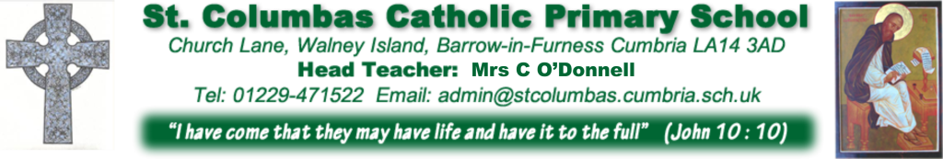

PARENTS EVENING – Autumn Term 2019

We will be having Open Evening for all classes week commencing March 25th 3:30-6:30pm to discuss your child’s progress. In addition to these dates teachers are offering extra times

They will be as follows:-

Class | Date & Time | Extra Dates & Times
Reception Class | Monday 25th November  3:30-6:30pm | Tuesday 26th November  3:30-5:00pm
Year 1 |  | Tuesday 26th November  12:30-6:00pm
Year 2 | Monday 25th November  3:30-6:30pm | Tuesday 26th November  12:30-3:00pm
Year 3 | Tuesday 26th November  3:30-6:30pm | Wednesday 27th November  3:30-4:30pm
Year 4 | Monday 25th November  3:30-6:30pm | Tuesday 26th November  3:30-5:00pm
Year 5 | Monday 25th November  3:30-6:30pm | Tuesday 26th November  2:30-5:00pm
Year 6  Children should attend with their parents | Monday 25th November  3:30-6:30pm | To be arranged at a later date, due to Kepplewray.

If you would like to make an appointment to see your child’s class teacher, please fill in the form below.

Yours sincerely,

Mrs C O’Donnell
Headteacher

ST COLUMBA’S CATHOLIC PRIMARY SCHOOL – Year _________

Child’s Name……………………………………………..

I would like an appointment to see my child’s teacher on:-

Monday 25th November Tuesday 26th November Other Date:____________

Signed …………………………………………..

