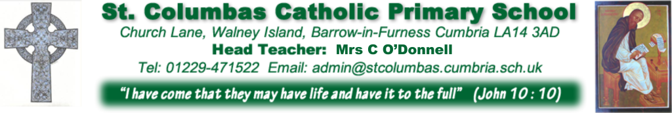
Dear Parents,
Due to staff absence levels we have decided to close St Columba’s School and Little Doves Nursery as of Friday March 20th at 3.20pm. We feel health and safety procedures cannot be followed without enough staff in school. We apologise for the inconvenience this will bring on our families; we have not taken this decision lightly.
I have asked Lesley our school nurse to set up the following sessions next week and through the holiday period if people need support.
﻿Telephone, FaceTime or Skype calls can be made.
Tuesday 13:00- 1530
Wednesday 8.30-12.00
Friday 1300 -1530

(This is for parent support on emotional and behavioural concerns. Any concerns for safety please contact your GP.
This is not an emergency contact.)

Any advice on the current situation with the Coronavirus please follow advice here

https://www.nhs.uk/conditions/coronavirus-covid-19/

School is due to re-open after the Easter break but obviously the news is changing daily. Parents will be contacted if school is not going to re-open after Easter.
In relation to work for the children at home:
staff have been asked to send you information for the class on Dojo/Tapestry/website. As I stressed in the previous letter reading and timetables is of high importance.
Finally take care and look after one another. It is a strange and surreal place to be at the moment as there are so many unknowns that are impacting on the whole world. May God bless our school community and all our families over the coming months.

Thank you once again for your support and understanding
Yours sincerely
Mrs C M O’Donnell

